DR.CLARKE’S CABIN

This scenario was written by Michael J Bertolini for use with the 7th Edition Call of Cthulhu RPG as part of Miskatonic Repository.  For personal use only.

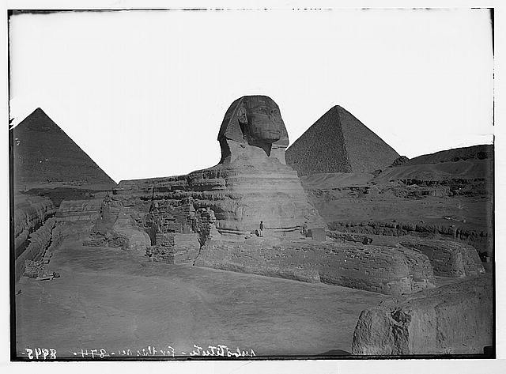

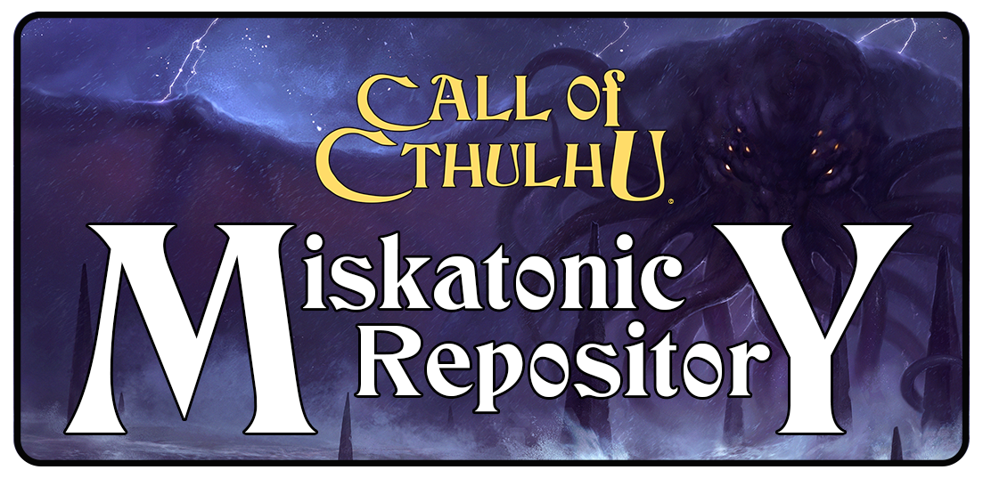

Credits

Story written by Michael J Bertolini

[www.michaeljbertolini.com](http://www.michaeljbertolini.com)

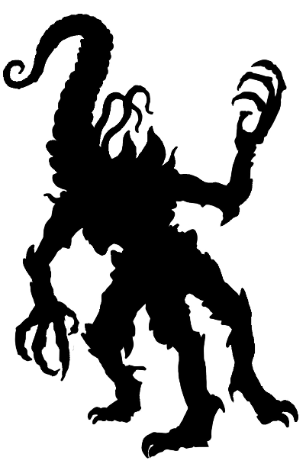

*Call of Cthulhu* is a Trademark of Chaosium Inc. and is used with their permission via the OBS Community Content program.

For more information please visit Chaosium’s website: [www.chaosium.com](http://www.chaosium.com)

The *Miskatonic Repository Logo* is used under license.

Dr. Clarke’s Cabin ©2020 Michael J Bertolini

Nyarlathotep silhouette is part of the Miskatonic Repository Silhouette Art Pack on www.drivethrurpg.com

“Egypt. Sphinx & pyramids. The Sphinx showing two pyramids in backgr[ound” Courtesy of the Library of Congress, LC-M32- 8945

“Phtah-Sokari. (Socharis.) [Ptah-Sokar]” From the New York Public Library RLIN/OCLC: 9061046RLIN/OCLC: 9061046Phtah-Sokari. (Socharis.) [Ptah-Sokar]Phtah-Sokari. (Socharis.) [Ptah-Sokar]Phtah-Sokari. (Socharis.) [Ptah-Sokar]Phtah-Sokari. (Socharis.) [Ptah-Sokar]

DR. CLARKE’S CABIN

Doctor William Clarke has gone missing, it is unclear what is behind his disappearance.  A researcher by trade, Dr. Clarke has travelled the world and likely made many enemies along the way.  Dr. Clarke is a well known individual, his disappearance is likely to attract attention and be reported in papers around the world.

keeper information

On the last dig Dr. Clarke was a part of, a shrine to Nyarlathotep was discovered.  While little was uncovered regarding the Black Pharaoh, a black Ankh was discovered which acts as a prison for several Children of the Sphinx (5 to be exact).  Dr. Clarke secreted the Ankh away, eventually learning of its secrets after countless hours of occult study, and set about learning various protection spells to keep the Ankh secured.

Dr. Clarke hid the Ankh in his cabin in Northern Vermont, carving Elder Signs everywhere but they are weak and prone to dissolution.  Unfortunately, Dr. Clarke suffered a stroke and has been unable to warn anyone concerning the Egyptian relic.

Roll a d100 (against INT 50) at the start of every day until you succeed; Roll a d100 (against LUCK 50) then.  The first Child of the Sphinx will be able to break out of its prison on the first success; after the second all protective wards will fade.  If the group of investigators are 4 or more, two Children of the Sphinx will escape.

This scenario occurs in mid 1920s Massachusetts, but can be adjusted with minor effort by the Keeper in regards to place and/or time period to suit their need.

involving the investigators

This scenario is meant for three to four investigators, though more or fewer could be handled (increase/decrease the number of Children of the Sphinx released at any given moment), either detectives or journalists.  The investigators would, ideally, have never met Dr. Clarke before but may know him from his reputation.

part one

The investigators will be contacted by a law firm that hopes to hire their services.  The law firm is looking for their client, to discuss business matters, and haven’t been able to reach him.  They provide the following information:

* Dr. William Clarke was an archaeologist for Miskatonic University until a year ago.
* Dr. William Clarke owns two homes, one in Arkham (73 Hill Street) and a hunting lodge in Vermont (address unknown).
* Dr. William Clarke’s wife passed 3 years ago, his son (Andrew) moved to London; the law firm has been unable to reach him though they have an address.

They will not, unless convinced (**Persuade**), pay any upfront fees to the investigators.  The law firm actually intends to refuse payment eventually, but will never divulge this information.

If the investigators try to contact Andrew, they will not be able to reach him.  If they intend to travel to England, they can find Andrew at the address provided by the law firm.  (about 7 days travel each way)

Andrew will state that he hasn’t seen or spoken to his father in over a year, prior to his trip to Egypt.  If pressed on the Egypt trip, Andrew says that he was never interested enough to care.

73 Hill Street, Arkham

73 Hill Street is a narrow house, part of a row of similar houses, which stands two stories tall. The second floor doesn’t completely cover the first floor, creating a long roof. The grass is overgrown and the vegetation thick. Nobody appears to be home.

If the investigators break-in to Dr. Clarke’s home in Arkham (**LUCK** to avoid being noticed by neighbors if done at night, Hard **LUCK** or combined **LUCK** and **STEALTH** rolls to avoid detection during the day) they can search, with little chance of potential harassment.  If they failed any roll, there is a 20% chance that they were noticed by neighbors; if they fumble or fail a pushed roll, the police have been called: searching requires Hard **Spot Hidden** rolls (unless otherwise noted) and the investigators have less than five minutes to search before the police arrive.

The investigators will find the following bits of information (and their suggested locations, the Keeper may move as appropriate), remember that rolls are only required if the investigators are rushing:

* The location of Dr. Clarke’s cabin in Vermont (on a bill in the Kitchen)
* The address of Andrew in London (don’t require a roll for this if the investigators have visited London) (near the recliner in the Living Room).
* Several books on Egyptian Hieroglyphics. (In the study)
* Several ‘travel’ books in English. (Various locations as appropriate)
* Several general interest books about Egypt in Arabic. (In the study)
* Several non-mythos related occult books (In the study).
* A locked safe in the master bedroom (In the Master Bedroom).

If the players are in a rush, they will not be able to find the following information; successful rolls are always required when not rushing:

* The combination for the safe in Dr. Clarke’s home (assuming they found the safe)
* Dr. Clarke’s notes concerning the Elder Sign (including **Handout 1**)
* Dr. Clarke’s Gun (Colt New Service)
* Ammunition for Dr. Clarke’s Gun

Similar checks are required when leaving as when breaking-in.  However, the investigators should be able to escape without issue even if seen; still, accurate descriptions of the investigators will be given to the police, investigators will be arrested on sight.

Miskatonic University

The investigators will likely want to get information from Dr. Clarke’s coworkers at Miskatonic University.  While there are seven professors on the list of Anthropology professors along with Dr. Clarke, though only one knew Clarke well enough to be able to provide information that the investigators have likely already found (George Johnson).  All other professors encountered will say that they didn’t know Clarke well but will point the investigators towards Johnson (no roll required).

When the investigators meet George, read or paraphrase the following:

George Johnson is an older man with stark white hair, balding head, and full beard.  He has tired, gray eyes and his skin has a leathery appearance. Confined to a wheelchair, he barely takes note of your presence.

Johnson will likely be in his office though he can be found around most parts of the Anthropology Department if the Keeper wishes to move him around.  If his office, the investigators (**Spot Hidden**) will notice a sign that reads ‘Dean of Anthropology’ beside Johnson’s door.

Johnson will provide the following information if convinced with a **Persuade**, while a **Psychology** roll will determine that he doesn’t want to be bothered by the investigators and will cooperate if they will leave:

* Clarke took a leave-of-absense during the fall semester (it is currently the Spring semester) to partake in an archaeological dig in Egypt.
* Clarke returned from Egypt two months prior.
* Clarke has not returned to Miskatonic University or Arkham (as far as Johnson knows).
* Clarke’s family owns a cabin in northern Vermont, near the Canadian border; Johnson doesn’t know its specific location.

Johnson is adamant that he has a class to teach and wants the investigators to leave (if the investigators have any schedule for the Anthropology department, they’ll know this is a lie; if not, **Psychology** knows this to be a lie.)

Johnson doesn’t know where the Egyptian dig took place nor what, if anything, was uncovered.

Arkham Police

Should the investigators not earn the wrath of the Arkham police, they can inquire for additional information.  Unfortunately, the police aren’t able to help beyond what information the investigators already know (they will not know anything about Egypt and will not discuss information concerning a break-in should that have occurred).

If any investigators were arrested, or are arrested at the police station, breaking out of lock-up should be treated as a chase sequence rolling as needed to avoid police detection (rolls will be at a disadvantage if done multiple times). Details of an escape are left up to the Keeper.

part two

Everyone has said that Clarke’s family owned a cabin in Vermont, though nobody knew exactly where to find it (only the bill in Clarke’s cabin gives the specific address).  If the PCs know of the cabin but not the location of the cabin, asking around the area (any social skill will do) will eventually lead the players to this place.

Keepers should read or paraphrase the following:

The cabin sat back from the road, its dark windows looking like a monster peeking out from beneath the wooden mass of trees and shrubbery in the unkempt yard.  A faded sign near the single parked car in the drive reads ‘Clarke’ giving the only clue to its identity.

The car is an Austin 7 (in production from 1922-1939), made in the UK but sold worldwide.  Should the investigators arrive before the Children of the Sphinx can escape, read the following:

The outside of the house looks poorly cared for, the sidewalk is cracked and spider webs are in every conceivable place.  The roof appears to sag slightly as though age and condition have taken their toll.

Should the investigators arrive after the Children of the Sphinx have been able to escape, read or paraphrase the following:

The outside of the house is a wreck.  Though obviously poorly cared for, the windows are smashed and the sidewalk is cracked where it isn’t smashed.  The door hangs from its hinges and the roof appears to sag from both age and damage.

Should they still be present, a **Spot Hidden** roll outside, prior to entering the house for the first time, notices strange markings on the door and window frames that appear to have been carved with a knife; once the house has been entered, a roll to see them is not required.  An **Occult** roll knows these symbols to be defensive and protective in nature while a **Cthulhu Mythos** roll knows them to be various Elder Signs and other protective wards.

Unless destroyed by the Children of the Sphinx, the door to the cabin is locked, requiring a **STR** to break open or **Lockpick** roll to unlock; neither the lock or door are in good condition, but note the damage done to the Elder Signs which would allow Children of the Sphinx to pass uninhibited.

Upon entering, the investigators will easily be able to see a letter tacked to the wall opposite the door. (Handout 2) Should they still be there, there are strange symbols on every surface; allow a roll to identify if not already done.  Grant a bonus die if these were seen outside but not identified. An **Occult** roll knows these symbols to be defensive and protective in nature while a **Cthulhu Mythos** roll knows them to be various Elder Signs and other protective wards.

The cabin will be pretty empty if the Children of the Sphinx haven’t escaped their prison (they will attack anything that they think is a threat), though a search will find Dr. William Clarke’s corpse in the bedroom (**Medicine** determines that he had a stroke; if used in a pulp campaign, consider allowing Dr. Clarke be alive long enough to tell the investigators that the Ankh is a prison but not live long enough to be treated with medicine).  A **Spot Hidden** in the study attached to the bedroom locates the Ankh.  The Ankh is not required for defeating escaped Children of the Sphinx, but putting the Ankh inside of an active Elder Sign will prevent more Children from escaping.

A successful **Archaeology** roll determines that the Ankh is clearly of Egyptian design, even though it is black rather than the traditional gold, but the construction suggests that it is meant to be inverted.  An **Occult** roll determines that an inverted Ankh is a symbol of death while a **Cthulhu Mythos** roll determines that an inverted black Ankh is a symbol for Nyarlathotep.  If a Hard **Cthulhu Mythos** roll is made, the investigator(s) know the following about Nyarlathotep:

Nyarlathotep enacts the will of Azathoth and other gods and is accurately referred to as their soul.  He always attempts to bring madness to humanity and several prophecies seem to state that someday Nyarlathotep himself will destroy humanity and possibly the entire planet.  The Black Pharaoh, one of Nyarlathotep’s forms, is an Egyptian-looking human.

Nyarlathotep is unlikely to be met in this scenario unless the Keeper otherwise decides it, stats have not been provided.  Rather, one or more Children of the Sphinx could be present as physical enemies.

Conclusion

To prevent more Children from escaping (there were a total of 5), the Ankh just needs to be placed within an Elder Sign. If all five Children have escaped, the Ankh is nothing more than jewelry that grants an additional 1d3 POW on any **Contact Nyarlathotep** spell, reducing the spell requirement appropriately.  If the investigators don’t know how to create an Elder Sign or they don’t trust Dr. Clarke’s journal, the Keeper can create an NPC in or around Arkham capable to complete this task. At the same time, finding the Ankh could serve as a link between other scenarios.

If the Investigators don’t bother with the Ankh, the remaining Children will be unleashed (Keeper: roll randomly to determine the animal type. The Children will destroy the nearest human settlement before migrating (Keeper’s choice as to where), killing everyone in their path.

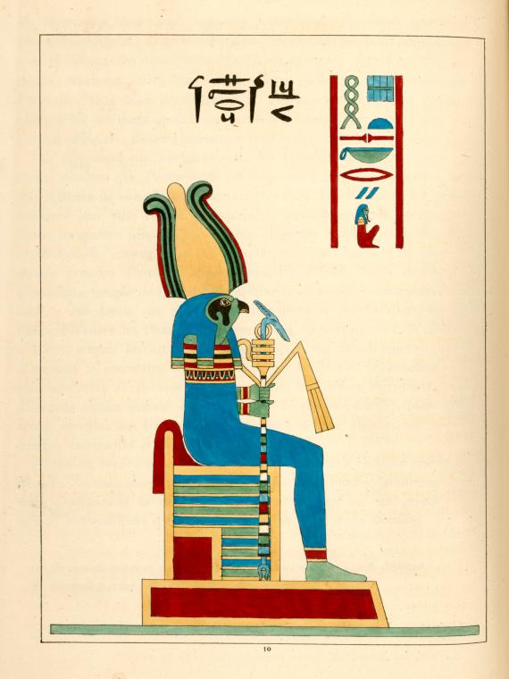

Children of the Sphinx

An **Archaeology** or **Occult** roll determines that a Child of the Sphinx can be any human-animal hybrid, likely inspiration for Egyptian theology.  A **Cthulhu Mythos** roll determine that a Child of the Sphinx is a human-animal hybrid that is possibly a child of one of Nyarlathotep’s forms.  If the Children escaped, it is up to the Keeper to decide where they are. Rolling 1d6 randomly determines animal type.

STR 70 CON 65 SIZ 50 DEX 35 INT 50

APP - POW 50 EDU - SAN - HP 11

DB: 0 Build: 0 Move: 8 MP: 10 Luck: N/A

Attacks per round: 1

FIGHTING: These creatures either physically strike their opponents or bite/gore/peck (depending on the animal; see below)

Fighting 55% (27/11), damage see below

Dodge 20% (10/4)

Armor: none.

Spells: none.

Skills: none.

San Loss: 0/1d8 to see a Child of the Sphinx

| ANIMAL (ATTACK) | DAMAGE |
| --- | --- |
| CHEETAH (BITE) | 1D6+DB |
| BULL (GORE) | 2D4+DB |
| CRODODILE (BITE) | 1D10+DB |
| HIPPOPOTAMUS (BITE) | 1D6+DB |
| FALCON (PECK OR CLAW) | 1D4+DB |
| IBIS (PECK) | 1D3+DB |

spells

**Elder Sign**

**Cost:** 10 POW

**Casting time:** 1 hour

The spell activates an Elder Sign. Each active Elder Sign takes a sacrifice of 10 POW to create, but costs no Sanity points. An Elder Sign may be formed into a leaden seal, carved in rock, forged in steel, etc. When made active beside an opening or Gate, it makes that path unusable to minions of the Great Old Ones and Mythos Gods, as well as to those greater beings themselves. Without the spell, the symbol itself means nothing and has no effect.

The writings of certain scribes apart, the Elder Sign is worthless in personal defense if the monster or minion can evade the Sign. Those wearing an Elder Sign around the neck, for instance, might gain protection for a few square inches of flesh where the Sign rests against the skin; however, the rest of the wearer’s body would be completely vulnerable.

weapons

|  |  |  |  |  |  |  |
| --- | --- | --- | --- | --- | --- | --- |
| **NAME** | **DMG** | **RANGE** | **ROF** | **MAG** | **HP** | **MALF** |
| Clarke’s Gun | 1d10 | 15m | 2(3) | 6 | 8 | 100 |

maps and handouts

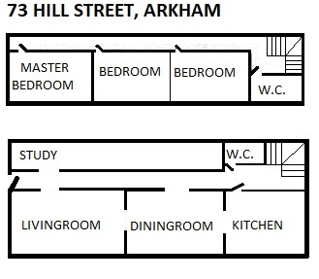

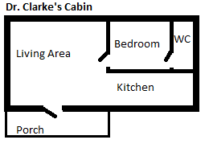

Handout 1

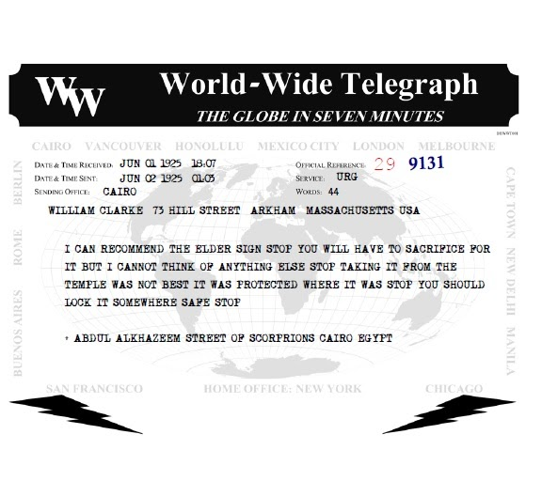

Handout 2

